19.2: a)
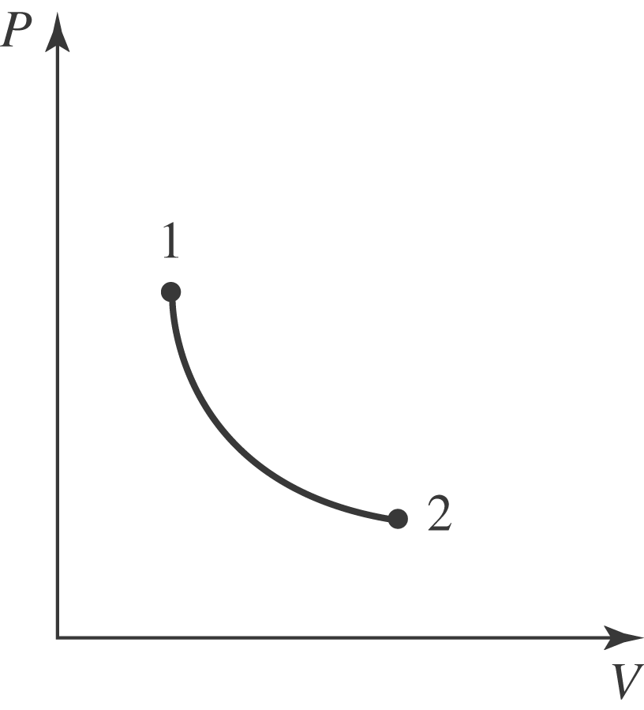
b) If the pressure is reduced to 40.0% of its original value, the final volume is 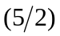of its original value. From Eq. (19.4),
